

Mobile Applications CA2
Project AI Timeline

Umar Raheem

B00152481

Department of Business
School of Business
TU Dublin - Blanchardstown
Dublin 15.

Word Limit for Assignment: - Actual Word Count: 858

Business & IT
Mobile Applications

Tools Used: 2
Ai Usefulness: 2
AI Limitations: 3

Tools Used:
ChatGPT – Used to create code, work through errors, learning unfamiliar concepts & generating examples.
Node.js & NPM – Installed packages and dependencies through the command prompt, these help support the applications foreseen operations
React Native – Main Framework for building the mobile application
Vs Code – Main platform used to manage code, document organization,
Command Prompt – Executed commands, installed dependencies & used to run react native commands
Firebase – Forecasted use was for authentication and storing data

Ai Usefulness:
I found that during this project, AI was very interesting, unexpected and fun to use.
It was interesting that I was able to get code from ChatGPT and because of the text I used to deliver the prompt my code would be explained step by step in a manner tailored specifically for me to understand. I believe it made this project more enjoyable, as much as we were mostly using AI, it taught me many things, and it is defiantly a new approach to assignments that are set up in this manner.
I feel like AI took me by surprise as I had a prejudice of AI as an almighty problem solver that would fail to give you a wrong answer, I was proved wrong, it is far from perfect. AI can give you errors, and it cannot answer all questions. The example I would provide in this situation would be the fact that my mobile and web version of the app failed to show any content. At the start of my project I didn’t pay mind to it as I had in my head that AI was permissible and ChatGPT would help me work pass this issue, but after hours thrown away on getting errors after making plenty of changes, deleting and reinstalling node dependencies, it finally dawned upon me that AI wasn’t the savior I expected it to be.
AI defiantly did help in speeding up learning and formatting small examples that could be further built on, this is something I used predominantly to increase the functionality and length of my code.

AI Limitations:
As discussed above ChatGPT has given me inaccurate information on multiple occasions during this product.
I have been installed with false hope, after 2 hours+ of making small changes and I would finally put it an error into ChatGPT for it to say, “I have found the problem, Guaranteed Fix”, this defiantly affected my moral.
Often ChatGPT was inefficient, giving me long answers for straightforward questions that required little to no explanation; after editing its response manner through prompts it would forget the approach, I had prompted it to follow which is why I render ChatGPT inefficient sometimes.
I believe with a project like this it is important to take responsibility for yourself to learn and understand what you are doing. When presented with an AI tool like ChatGPT, it is hard not to copy and paste everything without understanding, however what made the difference to me was understanding everything I was reading and extracting.

Summary:
Ai tools such as ChatGPT supported my React Native Mobile Applications project by explaining concepts, offering example components and helping debug errors. They were particularly useful for understanding navigation through the command prompt and while going through Node.js installs and dependencies.
AI also had its limitations such as occasionally providing overcomplex code or misdiagnosing issues when given limited context.
While the use of AI accelerated my learning and boosted the potential of my project, it sometimes risked reducing my understanding if overused or laziness substituted the hunger to understand.

AI Important Timeline:
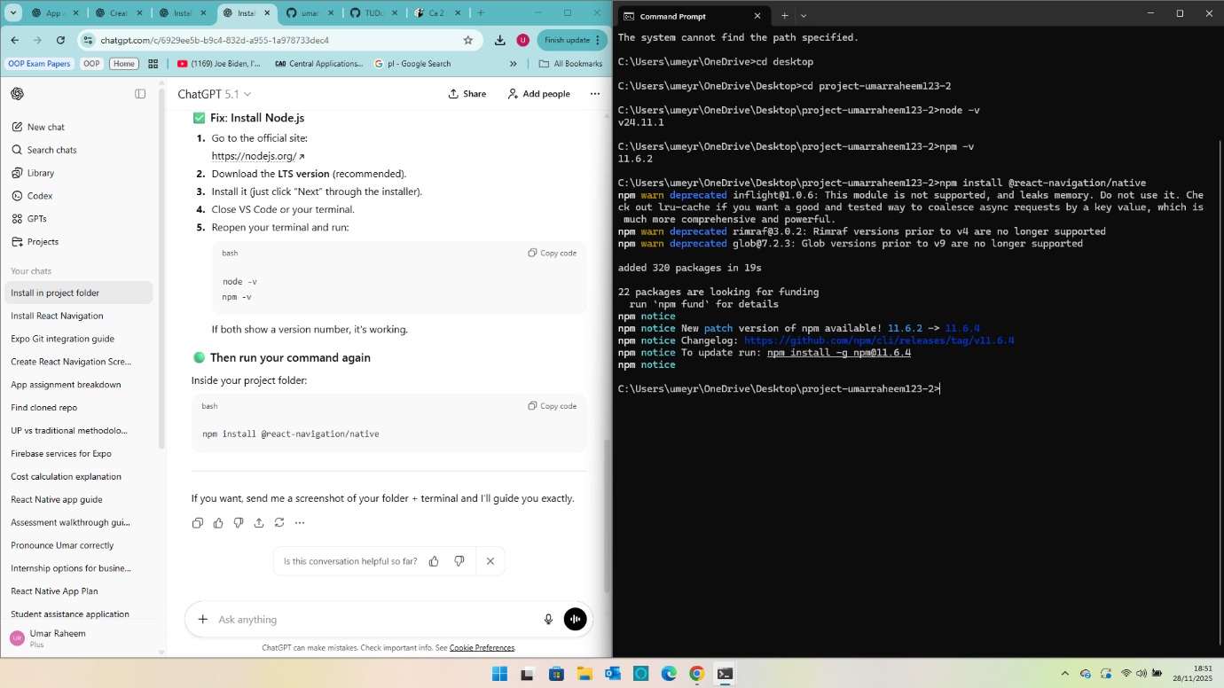
28/11 (18.51)
Started off my project by downloading NPM packages.
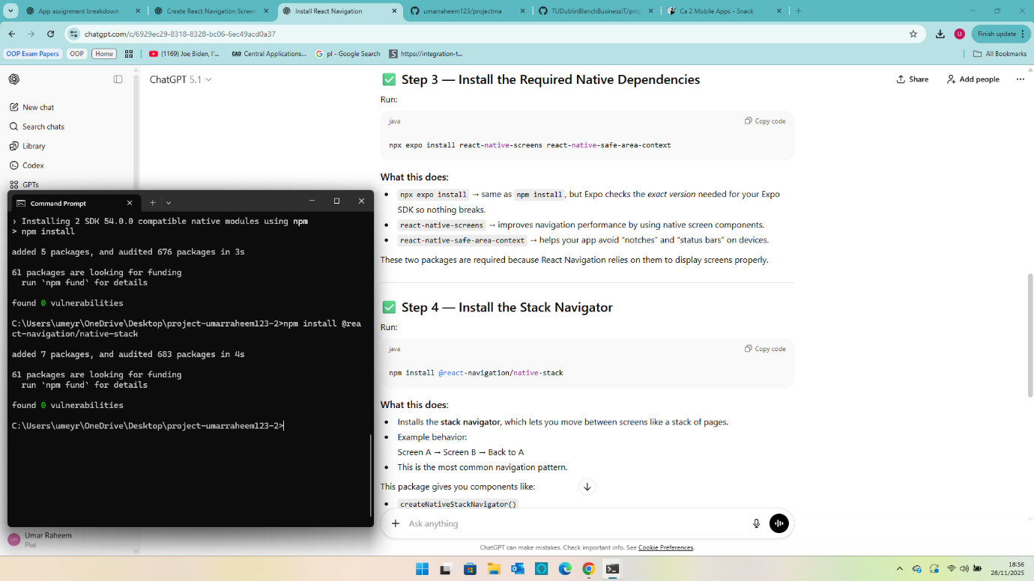
28/11 (18.56)
Downloading more NPM, NPX & Expo Dependencies
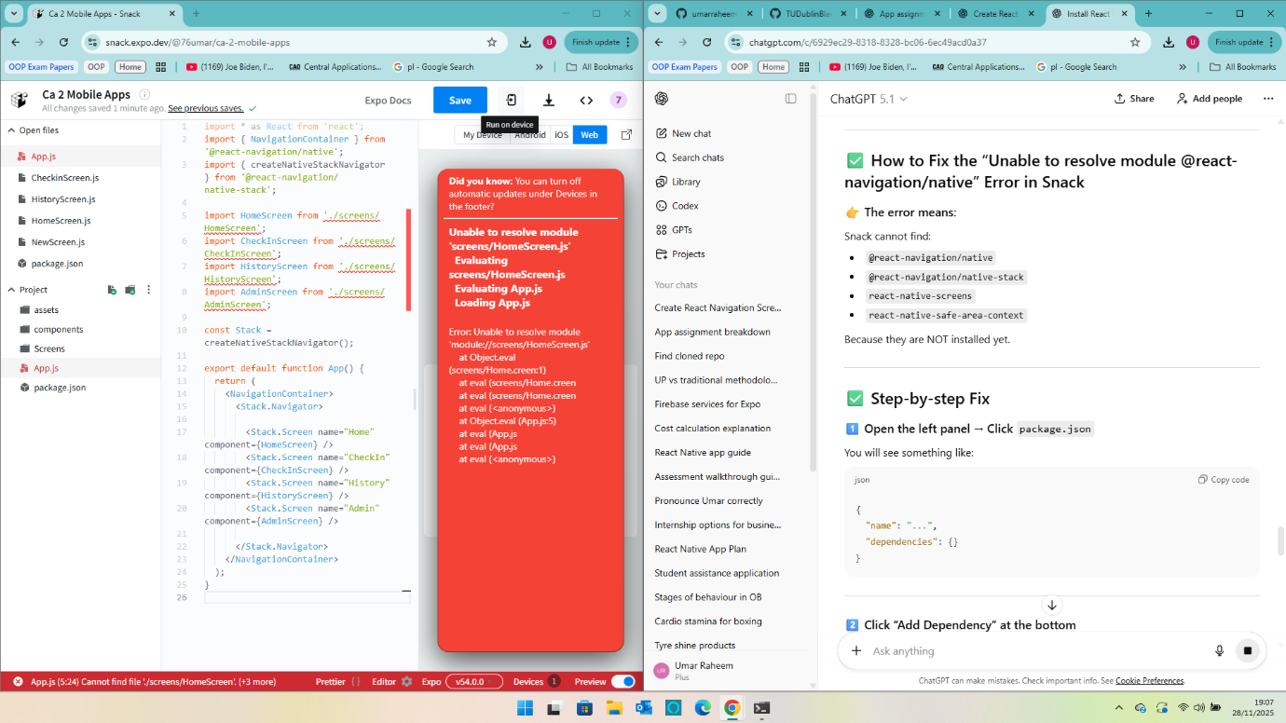
28/11 (19.07)
At this moment in time I didn’t understand that I would have to use VS Code.
Was trying to work through adding packages.
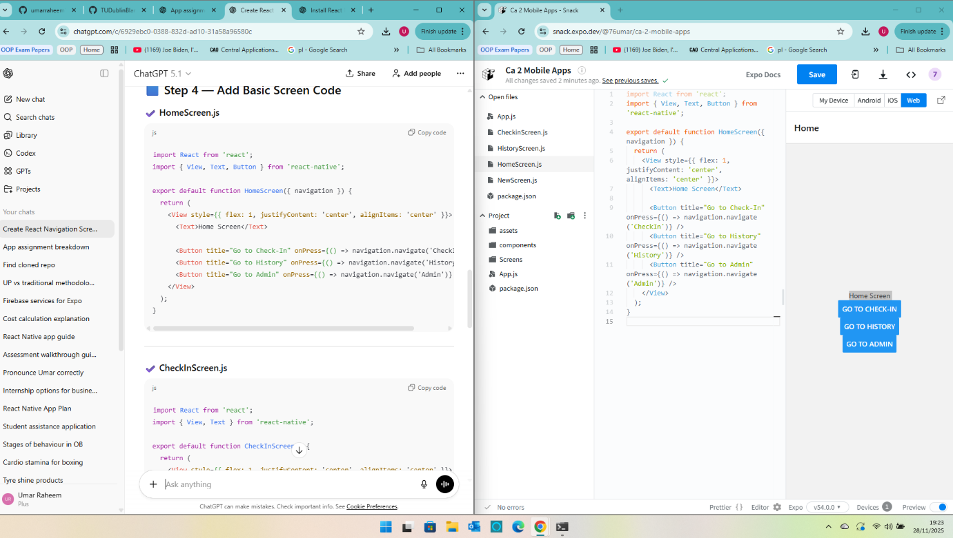
28/11 (19.23)
Created Navigation Buttons (Checkin & Admin Buttons weren’t working)
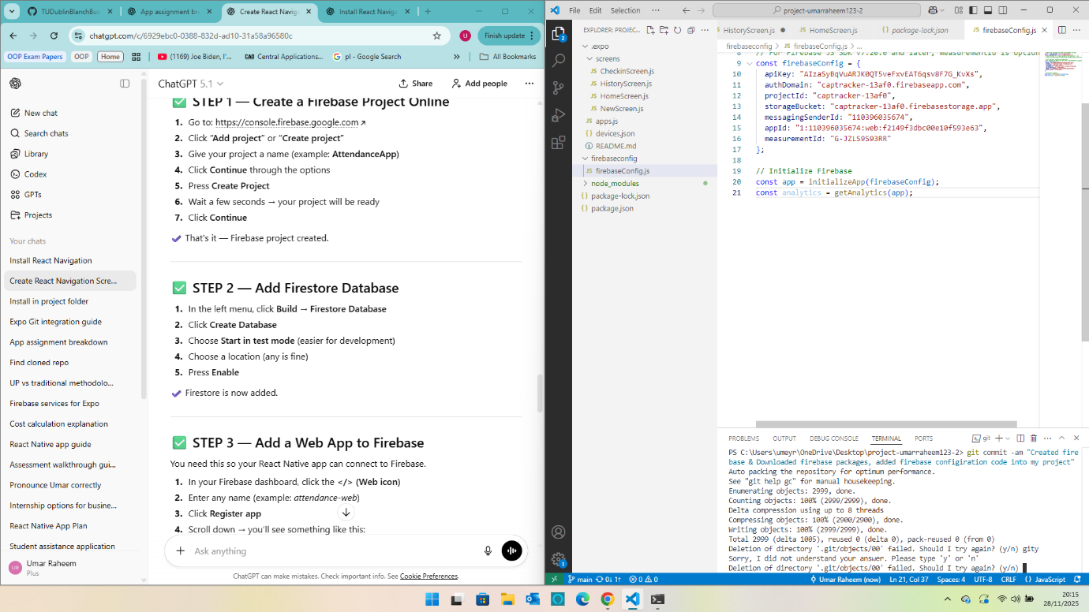
28/11 (20.15)
Created First version of firebase, Downloaded packages, working on connecting it to app
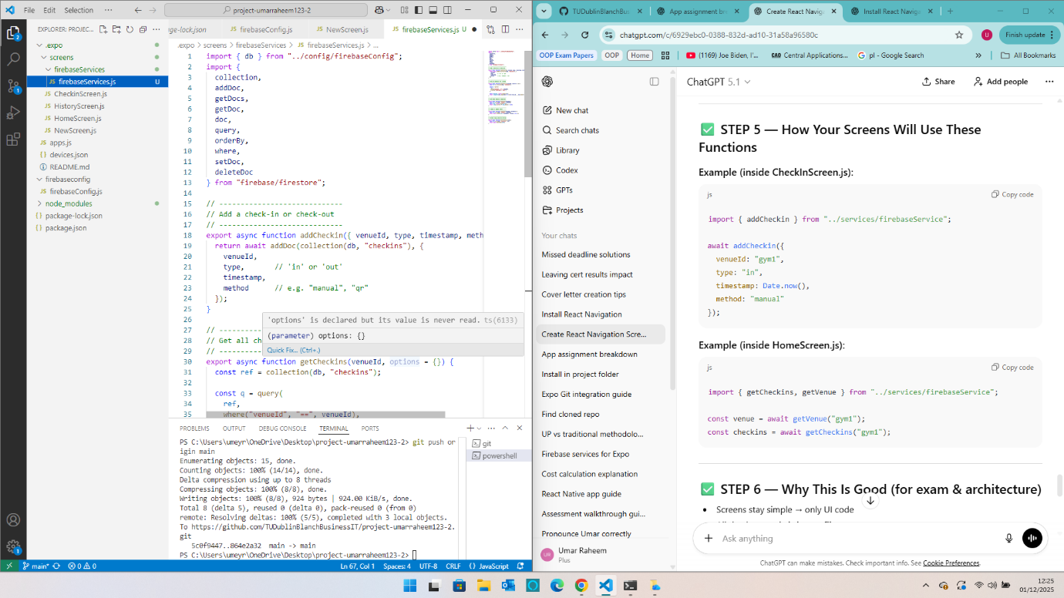
01/12 (12.25)
Firebaseservices.js created
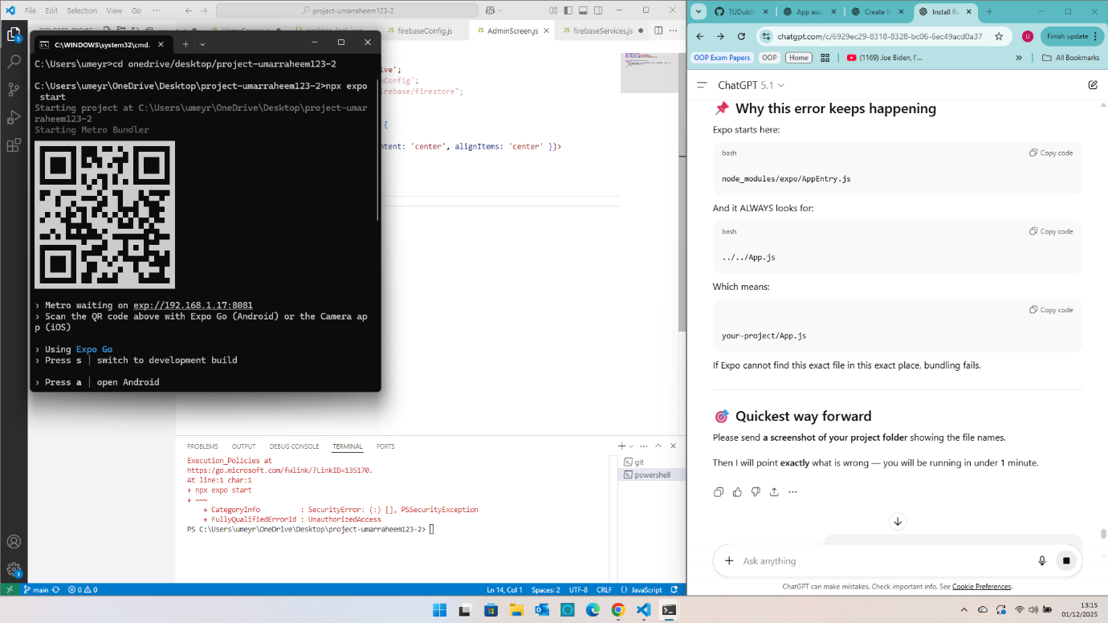
01/12 (13.15)
Attempted to get the app working on my phone (Fail)
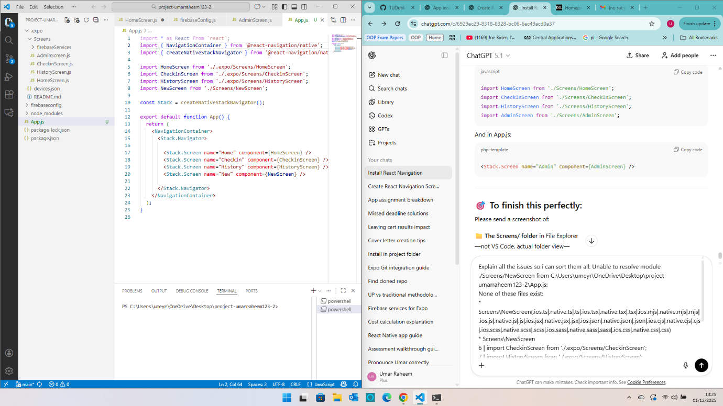
01/12 (13.25)
Encountered Issues running the app (Working through it)
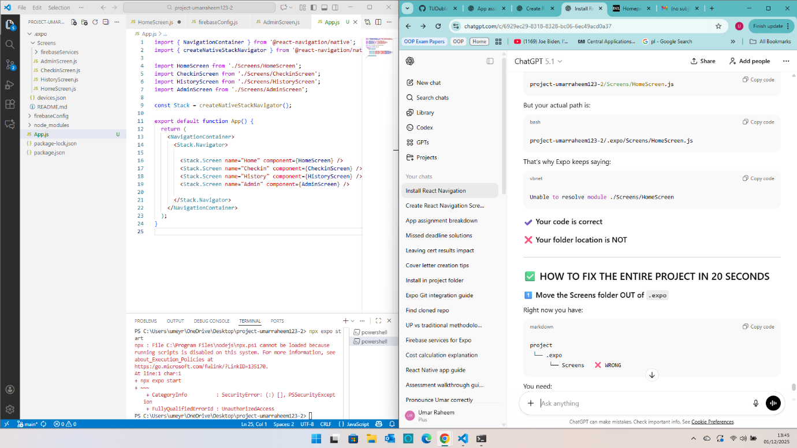
01/12 (13.45)
Thought I had found the issue (Location Path Issue)
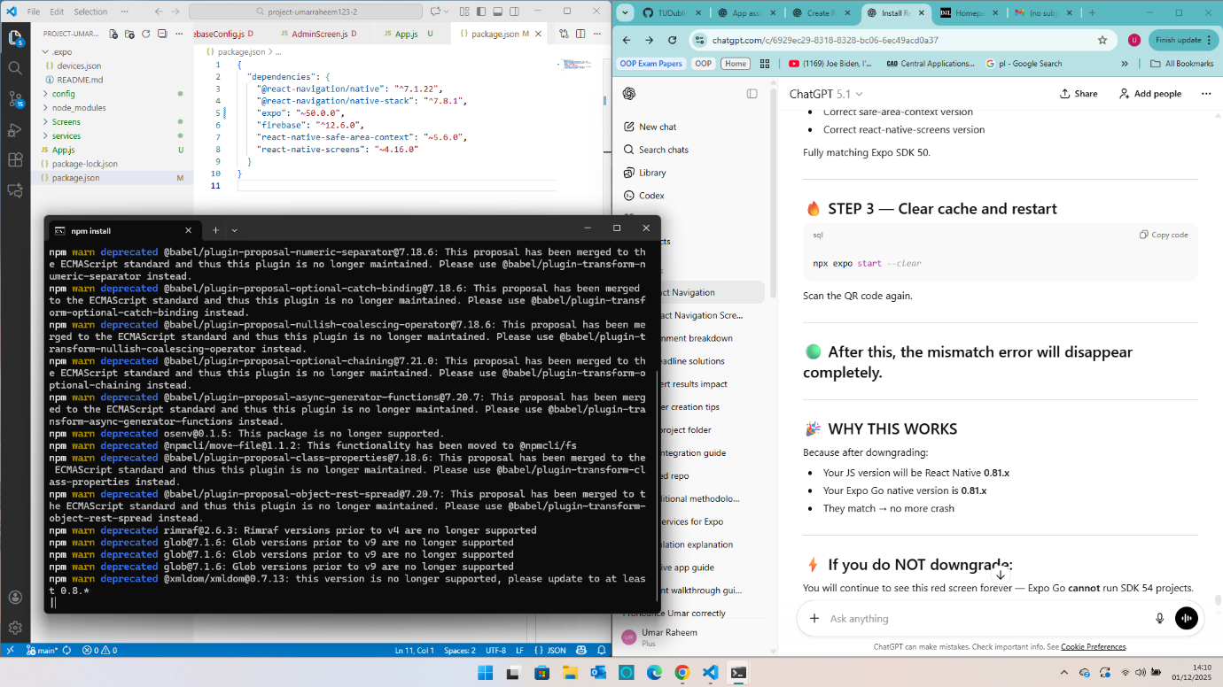
01/12 (14.10)
Expo version on my phone vs dependencies I installed were another issue
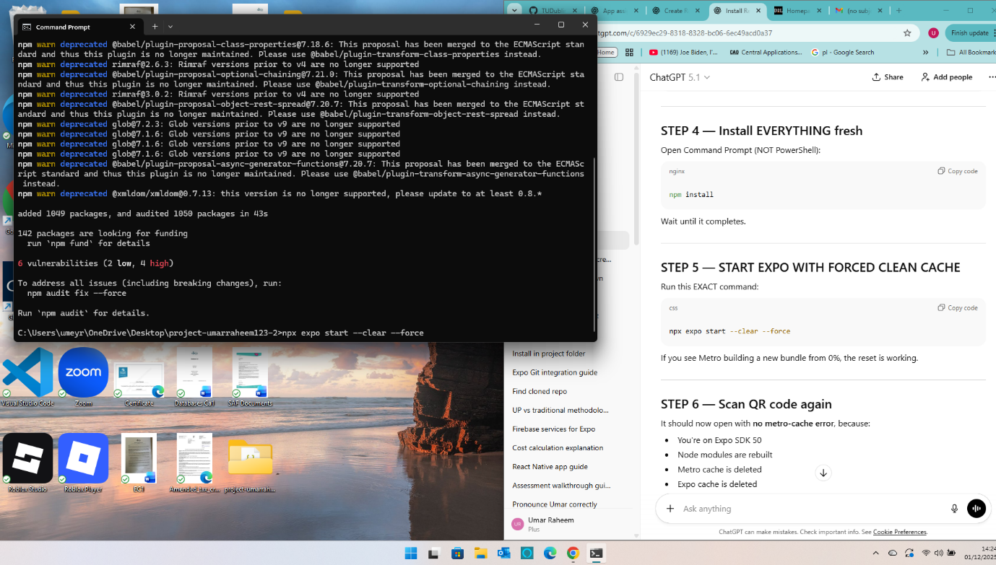
01/12 (14.24)
Working on fixing expo version, deleted and redownloaded modules (Did this multiple times)
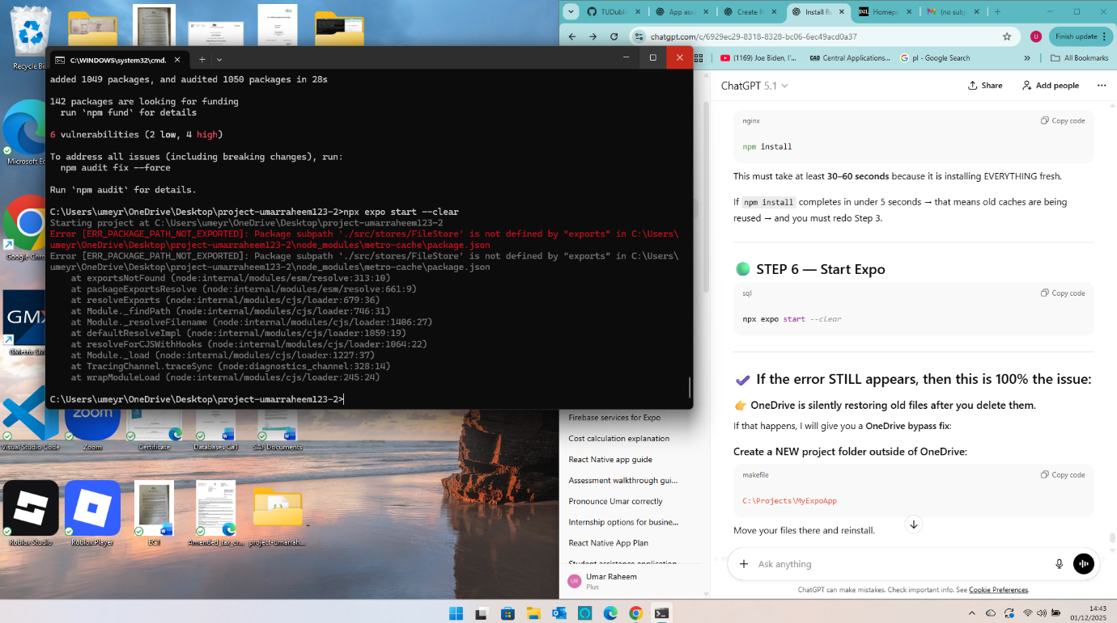
01/12 (14.43)
Deleted and redownloaded packages multiple times (Issue seemed to be OneDrive redownloading packages I deleted or keeping parts of them) I moved my project out of OneDrive.
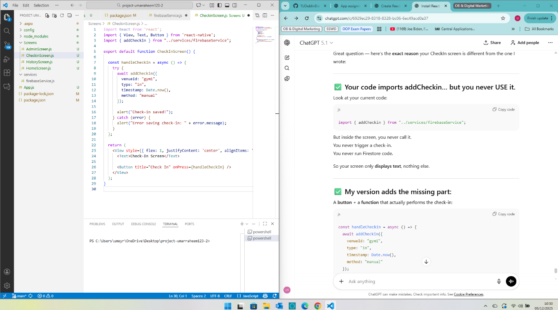
03/12 (10.30)
Called functions & buttons that were previously imbedded into my screens
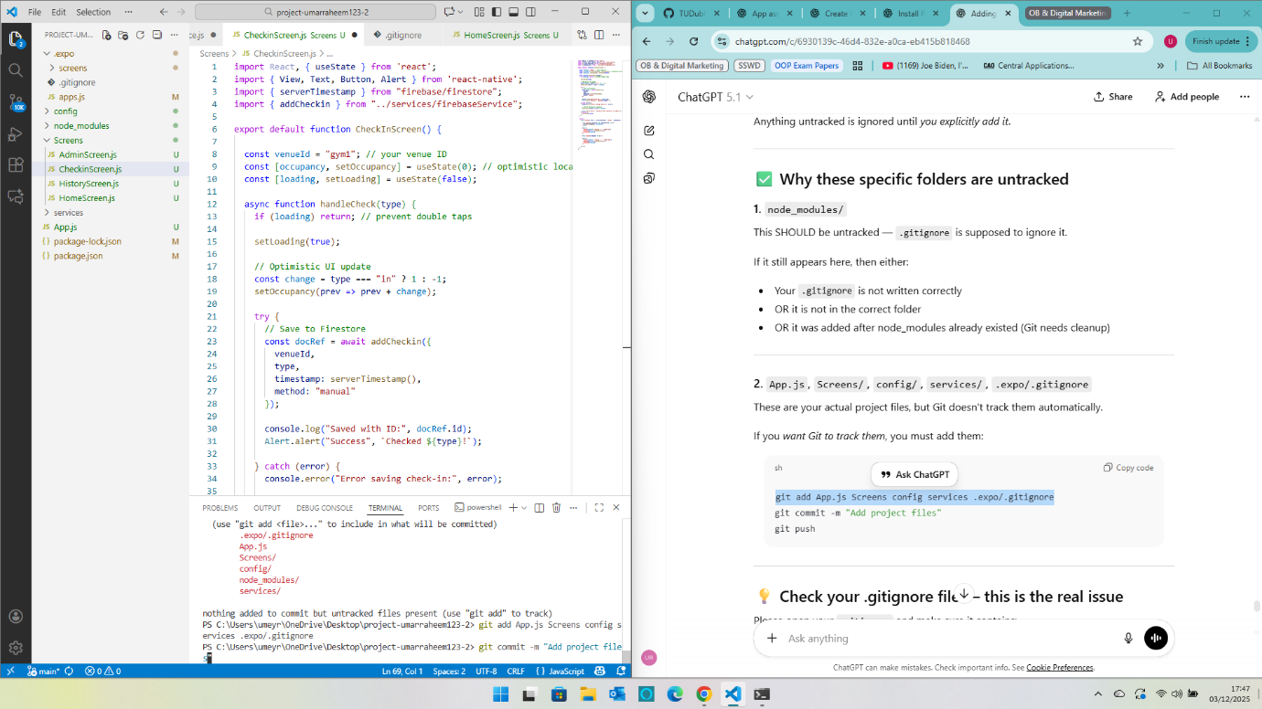
03/12 (17.47)
Had issues tracking my main project filed (Sorted by gitadd)
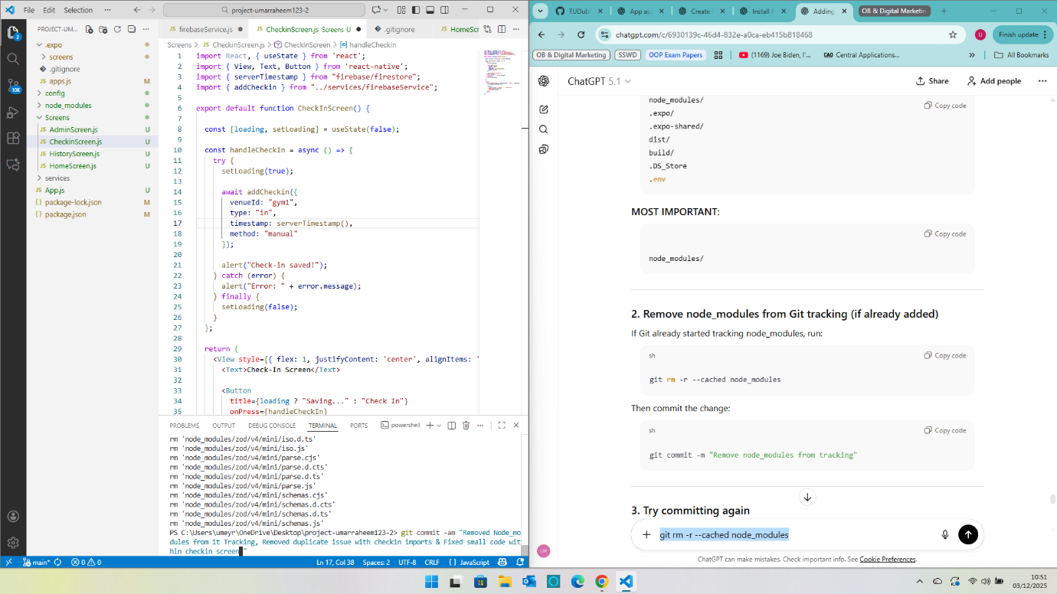
03/12 (10.51)
Removed Node_modules from tracking (Stopped using gitadd unless adding a new file)
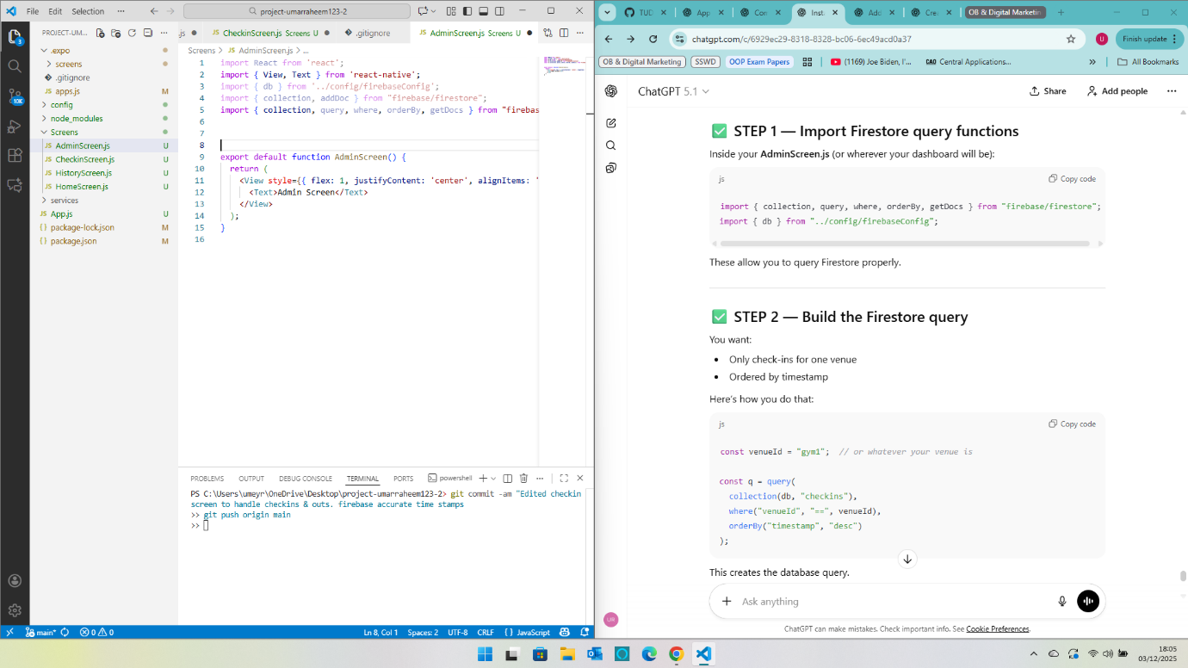
03/12 (18.05)
Working on importing firebase query
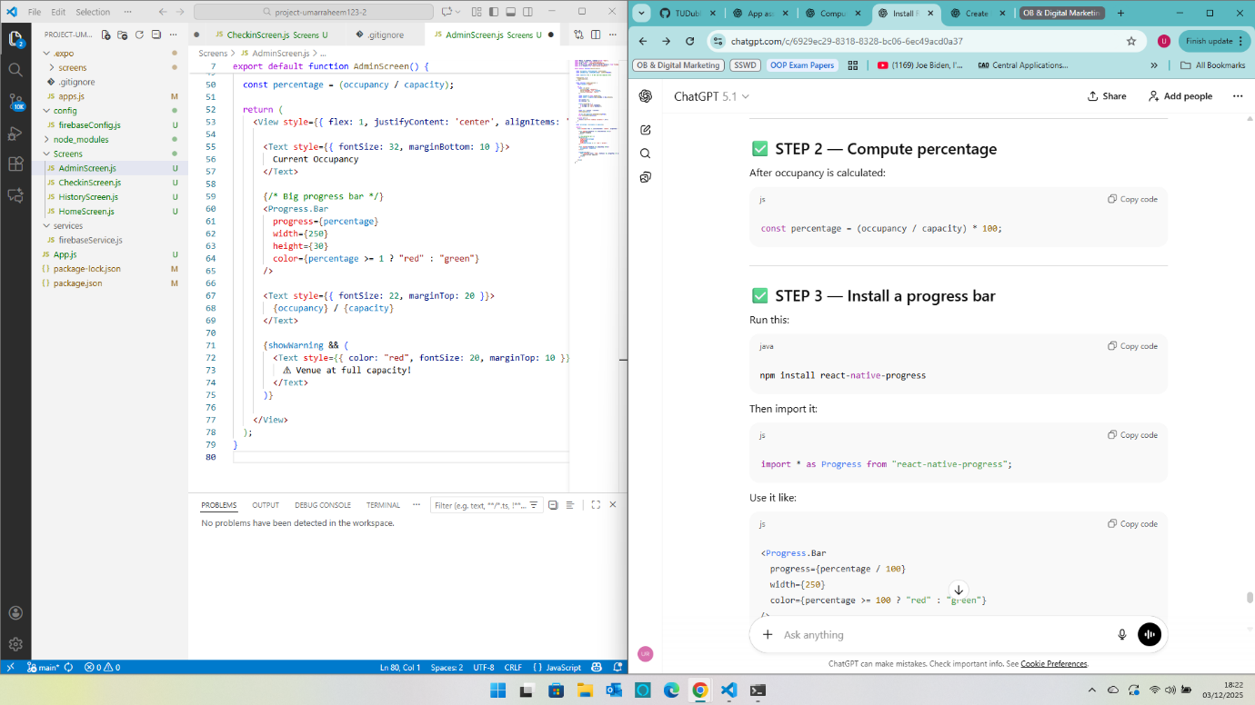
03/12 (Added Small features such as buttons & progress bars)
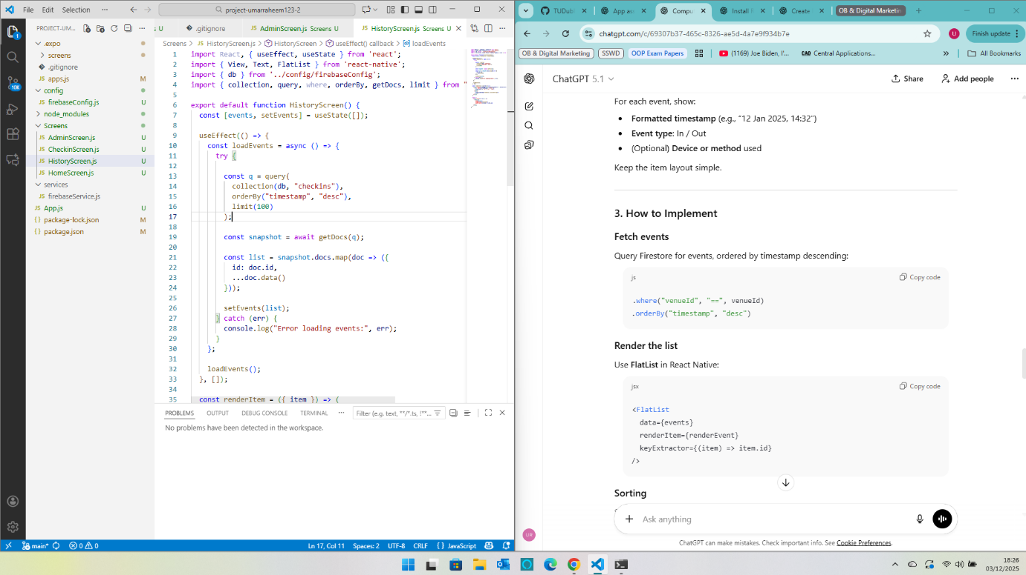
03/12 (18.26)
Updated History screen
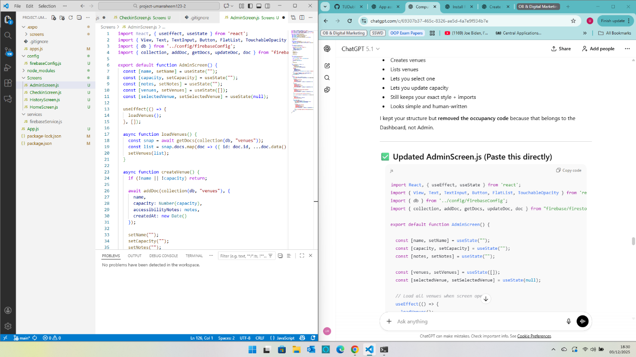
03/12 (18.30)
Updated Admin Screen
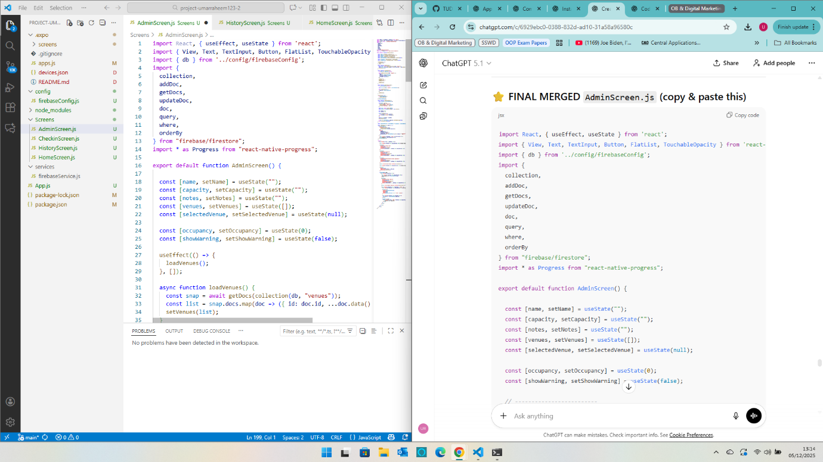
05/12 (13.14)
Merged previous code with new prompted code to get a cleaner layout also added a dashboard to Admin screen
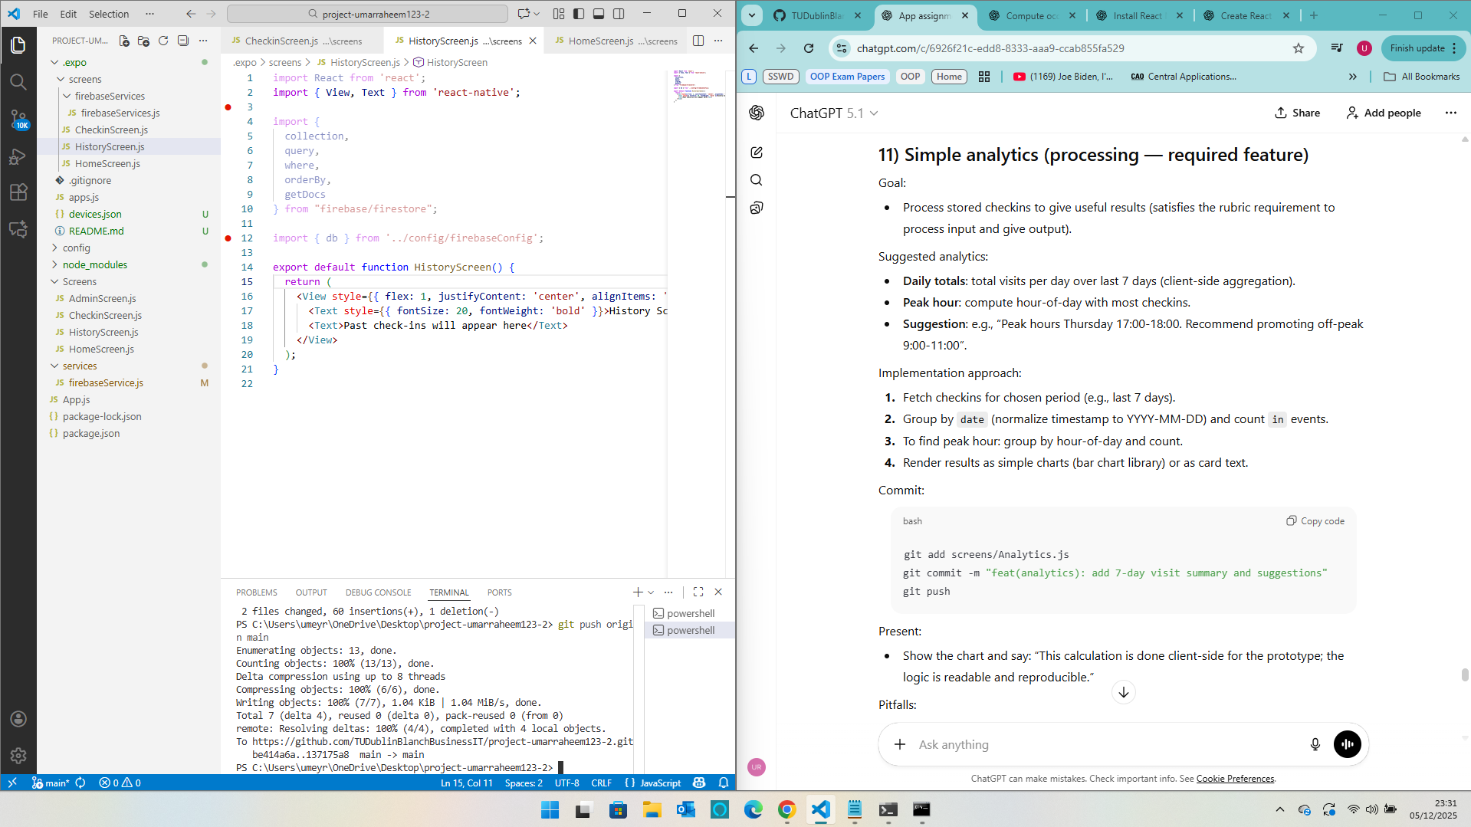
05/12 (23.31)
Working on adding simple analytical tools to History Screen

